Pharmacy Management and Control System (PMACS)

Use Case Specification Document

3.1
Sales Manager-Update Sales Promotions and Related Items content
Version No. 1.0

Project Document Revision History
Version Number | Date | Revision Author | Description of Revision
0.1 | 3/3/17 | Cindy Samano | First draft of document
0.2 | 3/4/17 | Cindy Samano | Update
0.3 | 3/5/17 | Cindy Samano | Adding more detail based on reviewing other team member use cases.
0.4 | 3/7/17 | Cindy Samano | Creating Swimlane Diagram, further defining the happy path, adding in more pre-conditions and Table of Contents.
0.5 | 3/8/17 | Cindy Samano | Adding in team revisions. Removing predecessors, removing some Pre-conditions and breaking apart post conditions.
0.6 | 3/9/17 | Cindy Samano | Adding in the Happy Path and Alternative flows. Finishing Swimlane Diagram to include error states.
0.7 | 3/10/17 | Cindy Samano | Revised Introduction. Minor grammar changes.
0.8 | 3/13/17 | Cindy Samano | Changes Actor from Sales Manager to Store Manager and add in Store manager description. Add in Uncouple related items error (items are not coupled) in post-conditions. Change Swimlane Diagram to show new actor and error.
0.9 | 3/14/17 | Cindy Samano | Changes Actor from Store Manager to Sales Manager, edit Actor description. Change Swimlane Diagram to reflect the change. Step-by-step update to the Happy path. Update Table of contents. Mention the coupons require a 12- digit numerical number. Include error states when the number is not numerical.
1.0 | 3/23/17 | Cindy Samano | Further define main and alternative flows to include all steps to end states. Change swim lane diagram. Deleted “Remove discount” on Company-wide sales. Changed the name “Company- wide sales” to “Item Discount”. Final revisions before 1 drafts of SRS.

Table of Contents
1. Introduction 4
2. Use Case Information 4
2.1 Actors 4
2.2 Use Case Interaction 4
3. Trigger 4
4. Pre-condition(s) 4
5. Post-condition(s) 5
6. Use Case Swimlane (Activity) Diagram 6
7. Main/Basic Flow(s) of Events (Happy Path) 6
8. Alternate/Exception Flow of Events 8
9. Assumptions/Business Rules including Non-Functional Requirements 12
10. Use Case Specification Review and Signoff 13

Introduction
The purpose of this use case will be to describe the functional and non-functional business requirements that occur when updating sales promotions and related items. User should be able to create and delete coupons that will provide discounts across whole orders, apply and remove Item Discounts on specific items, and update Related Items.

Use Case Information

Actors
Actor Name | Role | Description
Sales Manager | Main | The individual that runs sales reports, adjusts promotional settings such as Customer Coupons and Company-wide Sales/Discounts, and manages the Related Items feature.

Use Case Interaction
No predecessors/successors or interaction with other used cases.

Trigger
This use case is trigged whenever the Sales Manager selects the “Update Sales Promotion and Related Items” menu item from the main menu.

Pre-condition(s)

Items to receive Item Discount must be in the system.

Both items to be paired together must be in the system.

Post-condition(s)

Coupons added into the system.

Coupons deleted from system.

Item Discount applied on item.

Related items coupled.

Related items Uncoupled.

Item does not exist - error message displayed.

Error Creating Coupon – Coupon already exists, error message displayed.

Error Deleting Coupon - Coupon does not exist, error message displayed.

Error Coupling items - Item already coupled with another item, error message displayed.

Error Coupling items – X Item does not exist, error message displayed.

Error Uncoupling items – Items are not coupled, error message displayed.

Error Discount Format – amount is not 0-99, error message displayed.

Display message – Coupon number and percent amount message.

Display message – “Coupon Deleted”.

Display message - “Item Discount applied”.

Display message – “Items have been Coupled”.

Display message – “Items have been Uncoupled”.

Use Case Swimlane (Activity) Diagram 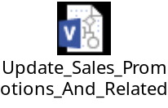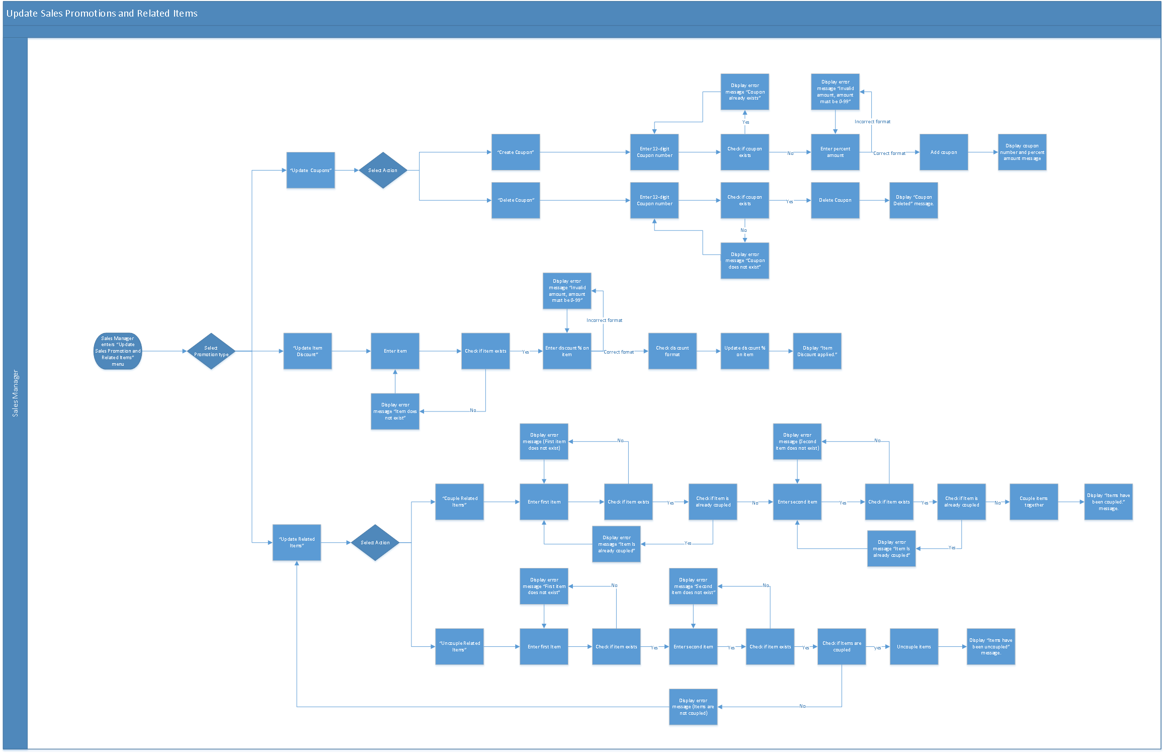

Main/Basic Flow(s) of Events (Happy Path)

Sales Manager enters the “Update Sales Promotions and Related Items” menu.
- Sales Manager selects “Update Coupons”.
- Sales Manager Selects “Create Coupon”.
- Sales Manager enters a 12-digit Coupon number.
- Coupon does not already exist.
- Sales Manager enters percent amount (0-99).
- Correct format for percent amount.
- Add coupon.
- Display Coupon number and Percent Amount message.

Sales Manager enters the “Update Sales Promotions and Related Items” menu.
- Sales Manager selects “Update Coupons”.
- Sales Manager selects “Delete Coupon”.
- Sales Manager enters a 12-digit Coupon number.
- Coupon exists.
- Delete Coupon.
- Display “Coupon Deleted” message.

Sales Manager enters the “Update Sales Promotions and Related Items” menu.
- Sales Manager selects “Update Item Discount” menu.
- Sales Manager enters item to apply discount.
- Item exists.
- Sales Manager enters discount % for item.
- Correct format for percent amount.
- Update discount % on item.
- Display “Item Discount Applied” message.

Sales Manager enters the “Update Sales Promotions and Related Items” menu.
- Sales Manager selects “Update Related Items” menu.
- Sales Manager selects “Couple Related Items” menu.
- Sales Manager enters first item to be coupled.
- First item exists.
- Sales Manager enters second item to be coupled.
- Second item exists.
- Items are not already coupled.
- Couple items together.
- Display “Items have been coupled” message.

Sales Manager enters the “Update Sales Promotions and Related Items” menu.
- Sales Manager selects “Update Related Items” menu.
- Sales Manager Selects “Uncouple Related Items” menu.
- Sales Manager enters items to be Uncoupled.
- Sales Manager enters first item.
- Item Exists.
- Sales Manager enters second item.
- Second item exists.
- Items are coupled.
- Uncouple items.
- Display “Items have been uncoupled” message.

Alternate/Exception Flow of Events

Sales Manager enters the “Update Sales Promotions and Related Items” menu.
- Sales Manager selects “Update Coupons” menu.
- Sales Manager selects “Create Coupon” menu.
- Sales Manager enters 12-digit Coupon number.
- Coupon already exists.
- Display error message “Coupon already exists”.
- Sales Manager re-enter 12-digit Coupon number.

Sales Manager enters the “Update Sales Promotions and Related Items” menu.
- Sales Manager selects “Update Coupons” menu.
- Sales Manager enters 12-digit Coupon number.
- Coupon does not exist.
- Incorrect format for percent amount.
- Display error message “Invalid amount, amount must be 0-99”
- Sales Manager re-enter percent amount.

Sales Manager enters the “Update Sales Promotions and Related Items” menu.
- Sales Manager selects “Update Coupons” menu.
- Sales Manager selects “Delete Coupon” menu.
- Sales Manager enters 12-digit Coupon number.
- Display error message “Coupon does not exist”.
- Sales Manager re-enter 12-digit Coupon number.

Sales Manager enters the “Update Sales Promotions and Related Items” menu.
- Sales Manager selects “Update Item Discount” menu.
- Sales Manager enters item
- Item does not exist
- Display error message “Item does not exist”.
- Sales Manager re-enter item.

Sales Manager enters the “Update Sales Promotions and Related Items” menu.
- Sales Manager selects “Update Item Discount” menu.
- Sales Manager enters item
- Item does not exist.
- Sales Manager enters discount %.
- Incorrect format for % amount.
- Display error message “Invalid amount, # must be 0-99”
- Sales Manager re-enter percent amount.

Sales Manager enters the “Update Sales Promotions and Related Items” menu.
- Sales Manager selects “Update Related Items” menu.
- Sales manager selects “Couple Related Items” menu.
- Sales manager enters the first item.
- First item does not exist.
- Display error message “Item does not exist”.
- Sales Manager re-enters first item.

Sales Manager enters the “Update Sales Promotions and Related Items” menu.
- Sales Manager selects “Update Related Items” menu.
- Sales manager selects “Couple Related Items” menu.
- Sales manager enters the first item.
- First item does exist.
- Item is already Coupled:
- Display error message “Item is already coupled”.
- Sales Manager re-enters first item.

Sales Manager enters the “Update Sales Promotions and Related Items” menu.
- Sales Manager selects “Update Related Items” menu.
- Sales manager selects “Uncouple Related Items” menu.
- Sales manager enters the first item.
- First item does exist.
- Item is not already coupled:
- Sales manager enters second item.
- Second item does not exist:
- Display error message “Item does not exist”.
- Sales Manager re-enters second item.

Sales Manager enters the “Update Sales Promotions and Related Items” menu.
- Sales Manager selects “Update Related Items” menu.
- Sales manager selects “Couple Related Items” menu.
- Sales manager enters the first item.
- First item does exist.
- Item is not already coupled:
- Sales manager enters second item.
- Second item does exist.
- Item is already Coupled:
- Display error message “Item is already coupled”.
- Sales Manager re-enters second item.

Sales Manager enters the “Update Sales Promotions and Related Items” menu.
- Sales Manager selects “Update Related Items” menu.
- Sales manager selects “Uncouple Related Items” menu.
- Sales manager enters the first item.
- First item does not exist.
- Display error message “Item does not exist”.
- Sales Manager re-enters first item.

Sales Manager enters the “Update Sales Promotions and Related Items” menu.
- Sales Manager selects “Update Related Items” menu.
- Sales manager selects “Uncouple Related Items” menu.
- Sales manager enters the first item.
- First item does exist.
- Sales manager enters the second item.
- Second item does not exist.
- Display error message “Item does not exist”.
- Sales Manager re-enters second item.

Sales Manager enters the “Update Sales Promotions and Related Items” menu.
- Sales Manager selects “Update Related Items” menu.
- Sales manager selects “Uncouple Related Items” menu.
- Sales manager enters the first item.
- First item does exist.
- Sales manager enters the second item.
- Second item does exist.
- Item are not coupled:
- Display error message “Items are not coupled”.
- Sales Manager returns to the “Update Related Items” menu.

Assumptions/Business Rules including Non-Functional Requirements
Be sure to number the assumption/business rules to allow easy reference to them. Business rules will be where non-functional requirements are recorded – have a way to specifically identify non-functional requirements.
9.1 Should be able to enter through the main screen in under 5 sec.

Use Case Specification Review and Signoff
Name | Project Team Role | Signature | Date
Erik Johnson | Team Lead | EJ | 3/24/17
Durwin Johnson | Developer | DJ | 3/24/17
Alex Pope | Developer | AP | 3/24/17
Cindy Samano | Developer | CS | 3/24/17
Fnu Jirigesi | Project Manager | FJ | 3/24/17

